|  |
| --- |
|  |
| Apache CloudStack 4.15 Installation Guide |
|  |
| Utilizing VMware, CentOS7, and KVM |

March 29, 2021

Author: Logan White

Version: 1

Apache CloudStack 4.15 Installation Guide

Utilizing VMware, CentOS7, and KVM

Contents

Introduction 2

Installation 2

Configuration 16

Usage Tips 20

Creating a Virtual Private Cloud 20

Adding an Instance 22

Uploading ISO / Template Creation 23

Customizing Basic UI 24

Results 26

Notes 26

References 28

Apache CloudStack 4.15 Installation Guide

Utilizing VMware, CentOS7, and KVM

# Introduction

The goal of this guide is to walk you through the complete beginning to finish installation of Apache CloudStack on CentOS7, utilizing VMware on the host and KVM inside of the virtual machine. The management server and the agent will be installed on the same host. It is recommended you review the “Notes” section of this guide before proceeding with the installation.

**Estimated Time to Completion**: 2 hours

# Installation

First, you need to make sure you are booted into VMware mode. Once done, start VMware Workstation.

Next, we need to get the CentOS 7.9 ISO from <http://mirror.cs.pitt.edu/centos/7.9.2009/isos/x86_64/>. The CentOS-7-x86_64-DVD-2009.iso will work.

In VMware workstation, go to Edit > Virtual Network Editor.

For this scenario, we will be utilizing a NAT Network. Click on **VMnet8** if it exists, and if not, create it by selecting **Add Network**.

For this guide, we will be utilizing the subnet network of **192.168.72.0**, with a subnet mask of **255.255.255.0**. The gateway we will be utilizing is **192.168.72.2**.

Modify the network information to make sure NAT is selected. Also, **disable DHCP**. Record the network information as you will need it for later.

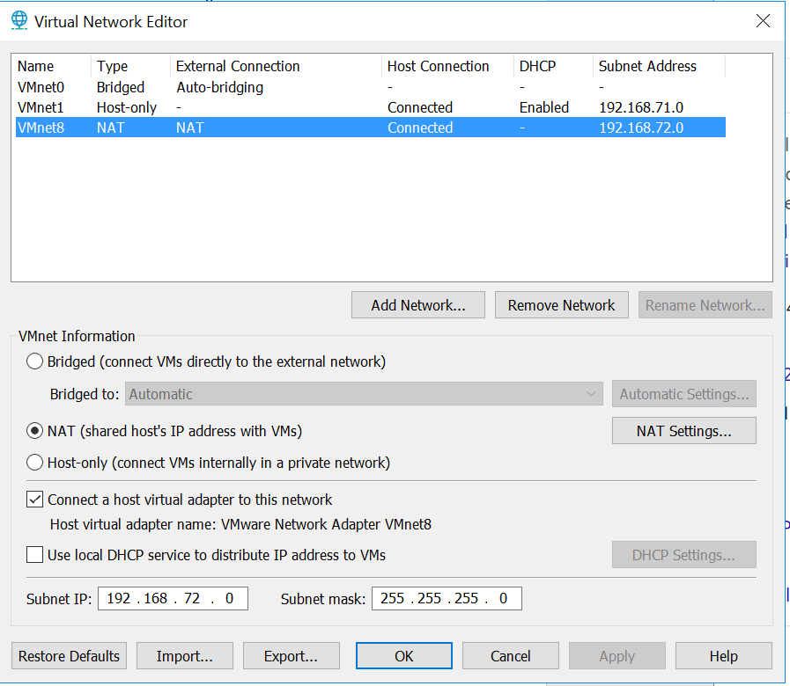

Figure 1, Network settings

Open NAT settings. Verify and record your gateway IP address. Next, open DNS Settings at the bottom of the menu. Configure it so it looks like Figure 2 (replace with your preferences).

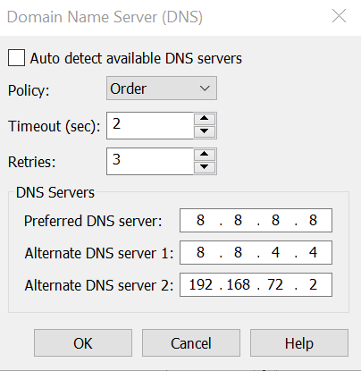

Figure 2, DNS Settings

When you are done, press OK and exit back to the main menu. We will now begin creating our virtual machine. Press **New Virtual Machine**. **Create a custom (advanced) machine**.

This guide has utilized the **ESXi 7.0** hardware compatibility configuration. CloudStack should work on Workstation 16 if you would prefer using that. For the ISO, utilize the **CentOS 7.9 ISO** you downloaded at the beginning of this guide.

When configuring the resources that will be given to the virtual machine, you should accommodate for the virtual machines that will be running on top of this one. Each VM will generally require 1 core, 512MB of ram, and 5GB to 20GB storage space. For this installation, I created a VM with 4 cores, 4GB of ram, and 250GB storage space.

Make sure to select NAT in network type. The I/O controller type this installation will utilize is the LSI Logic, and the virtual disk type will be SCSI.

Once the VM is done initializing, click on **VM > Settings**.

Make sure the network adapter is utilizing your custom network adapter.

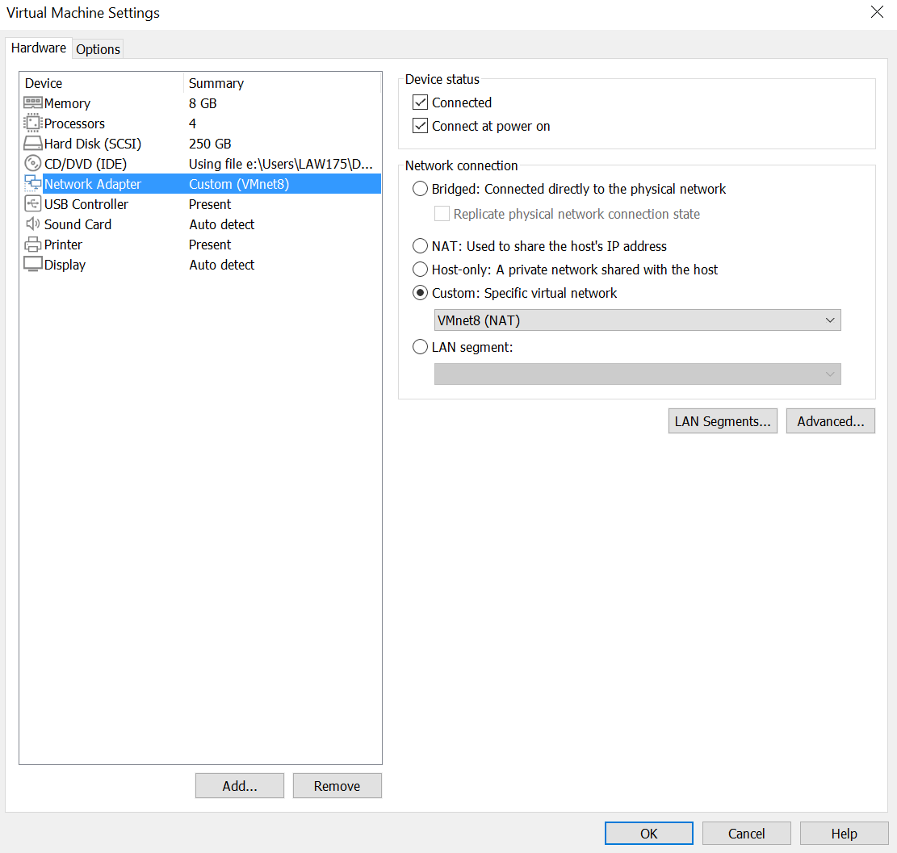

Figure 3, VM Settings

As shown in Figure 3, click on **Advanced**. Remember this location for your MAC Address. VMware should automatically generate a MAC address once the machine is installed, but you can generate one now if you would like.

Also shown in Figure 3, under Processors, **check the box** labeled “**Virtualize Intel VT-x/EPT or AMD-V/RVI**.” This will allow for nested virtualization.

In the Options tab on the top of the same menu, make sure that the virtual machine is utilizing your chosen guest operating system type (Linux). You should now be done configuring your virtual machine.

Once done, start the virtual machine. Once you get to the installation summary screen, select **Software Selection**. For this guide, I utilized the **Server with GUI** option. You may want to do a minimal install to save resources, but I chose the GUI to make it easier to access the CloudStack Interface.

Under System, select **Installation Destination**. I utilized the automatic partitioning feature to make things easier, but you may want to manually partition your virtual drive. If so, do so now.

Under Network, configure your network adapter. Go to IPV4 Settings and select Manual from the drop-down menu. There, click add and add in the IP address of the machine. This should be the IP that you plan to utilize for the management server. I utilized the IP address of **192.168.72.3**

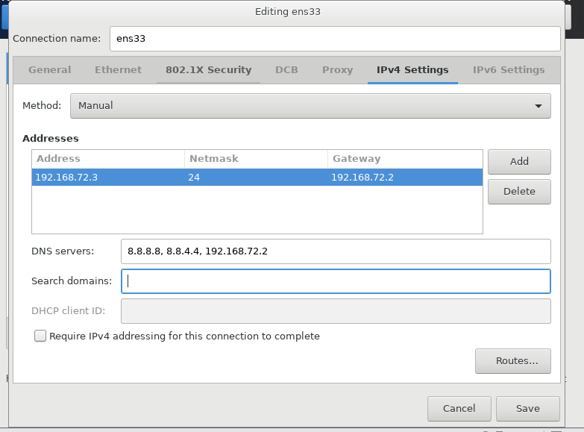

Figure 4, Connection Config

Configure the interface similarly to Figure 4. Once done, disable IPV6 in IPV6 settings. Then, click save and exit. You can then enable the interface. If it does not stay on and connected, you will want to verify your network settings are correct before proceeding.

If everything is how you would like, you can go ahead with the install. You should now be able to configure your root password and user. Wait for the installation to complete.

Once the installation has completed, open a new terminal. For the rest of this guide I will be utilizing the **SU command to become the super user**, so as to not have to utilize the sudo command. This could be dangerous, so to mediate that, I will be creating frequent snapshots so I will be able to revert back easily and with little progress lost. It is recommended you also create frequent snapshots.

Update your system with the command **yum -y upgrade**. If the command gives errors because it is sleeping, run **systemctl stop packagekit** and then retry. It is recommended that you reboot and take a snapshot before proceeding.

Once your system is updated, run the command **hostname --fqdn**. This will probably return localhost, which is not what we want. CloudStack requires a unique hostname and domain for things to work properly. To remedy this, open **/etc/hosts/.**

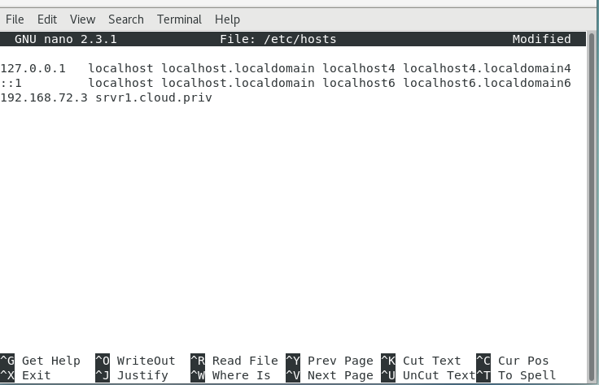

Figure 5, Host File

As shown in Figure 5, add the line **<yourip> srvr1.cloud.priv**. Reboot the system, and run the **hostname --fqdn.** If it does not change, utilize the command **hostnamectl set-hostname srvr1.cloud.priv**

Once done, run the command **yum install bridge-utils net-tools -y**

Next, we will modify the interface files to create the bridges that CloudStack requires. In the **/etc/sysconfig/network-scripts/** directory, create the following files**: ifcfg-cloudbr0 ifcfg-cloudbr1**. It is required that these bridges are named as stated.

In the same directory, find the name of your default interface. For me, that is the ens33 interface. We will need to create a **VLAN** for that interface, so create the file **ifcfg-ens33.200** in the same directory.

You should now have the following similarly interfaces**: ifcfg-cloudbr0**, **ifcfg-cloudbr1**, **ifcfg-ens33**, and **ifcfg-ens33.200**. If you have **the ifcfg-lo** interface, you can safely ignore it.

Open the file of your default interface. I will open it utilizing the command **nano /etc/sysconfig/network-scripts/ifcfg-ens33.** Replace the text within the following:

TYPE="Ethernet"

BOOTPROTO="none"

NAME="ens33"

UUID=" "

DEVICE="ens33"

HWADDR=" "

ONBOOT="yes"

BRIDGE="cloudbr0"

UUID should be the default. If there is no UUID, it can be generated by utilizing the command **uuidgen**. Be sure to do this for any other interface that required a UUID. Under **HWADDR**, put in the **MAC address** you generated earlier.

Now, open the interface **ifcfg-cloudbr0**. Replace the fields with your own information. Be sure to generate a UUID for the UUID field.

TYPE="Bridge"

BOOTPROTO="none"

IPV6INIT="no"

IPV6_AUTOCONF="no"

NAME="cloudbr0"

UUID=""

DEVICE="cloudbr0"

ONBOOT="yes"

DELAY="5"

IPADDR="192.168.72.3"

PREFIX="24"

GATEWAY="192.168.72.2"

DNS1="8.8.8.8"

DNS2="8.8.4.4"

DNS3="192.168.72.2"

STP="yes"

We will now create the second bridge for your VLAN network. Open the **ifcfg-cloudbr1** interface and add in the following information:

DEVICE="cloudbr1"

TYPE="Bridge"

BOOTPROTO="none"

IPV6INIT="no"

IPV6_AUTOCONF="no"

DELAY="5"

ONBOOT="yes"

STP="yes"

Finally, we need to modify the VLAN file. The HWADDR should be the same as your default interface. Open ifcfg-ens33.200 and add the following information:

BOOTPROTO="none"

DEVICE="ens33.200"

HWADDR="00:50:XX:XX:XX:XX"

ONBOOT="yes"

DELAY="5"

STP="yes"

VLAN="yes"

BRIDGE="cloudbr1"

You should now be done configuring your interfaces. **Reboot your system**. Run the following commands: **systemctl status network**, **systemctl status NetworkManager**, and **ping cloudstack.apache.org**.

Verify that there are no errors with your network and that it started correctly, as well as the Network Manager. If these display errors, then there is probably an issue with your configuration. You should be able to ping successfully. If not, but you are able to ping your gateway, check your DNS settings.

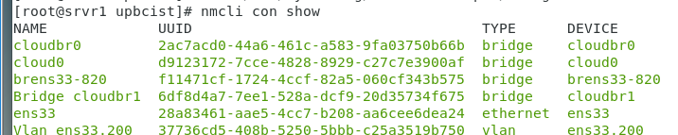

Figure 6, nmcli con show

Figure 6 shows how nmcli should look when running the command **nmcli con show**, with the exception of brens33, which you can ignore. This will be created when you configure CloudStack later. If your network is setup correctly and is working, you are free to move on to the next step.

Disable SELinux by running the command **setenforce 0** and then editing the file **/etc/selinux/config** and setting **SELINUX=permissive.**

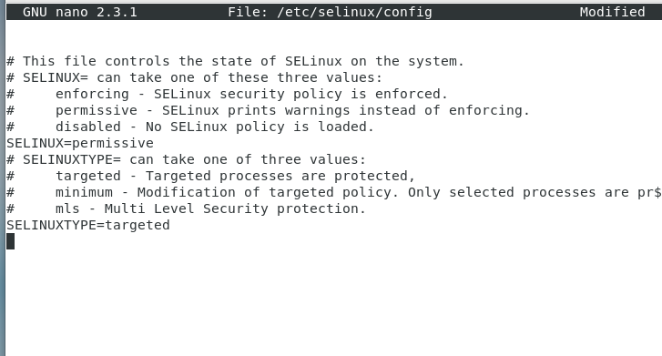

Figure 7, Selinux

The firewall can cause issues with the installation, so we will disable it with the command **systemctl stop firewalld**, and **systemctl disable firewalld**. This guide will be utilizing the **iptables** firewall later.

Run the command **yum -y install ntp** and enable it using **systemctl enable ntpd, systemctl start ntpd**.

Install Chrony if you don't already have it installed with the command **yum install chrony**.

We will now need to add the CloudStack repository to be able to install it. Create and edit the **/etc/yum.repos.d/cloudstack.repo** file. Add the following lines:

[cloudstack]

name=cloudstack

baseurl=http://download.cloudstack.org/centos/$releasever/4.15/

enabled=1

gpgcheck=0

We will now modify the iptables rules to allow for port forwarding and make sure connections are not blocked. (See Note 3 for some needed details before continuing.) First, define the variable **NETWORK=192.168.72.0/24** (your network)

iptables -A INPUT -s $NETWORK -m state --state NEW -p udp --dport 111 -j ACCEPT

iptables -A INPUT -s $NETWORK -m state --state NEW -p tcp --dport 111 -j ACCEPT

iptables -A INPUT -s $NETWORK -m state --state NEW -p tcp --dport 2049 -j ACCEPT

iptables -A INPUT -s $NETWORK -m state --state NEW -p tcp --dport 32803 -j ACCEPT

iptables -A INPUT -s $NETWORK -m state --state NEW -p udp --dport 32769 -j ACCEPT

iptables -A INPUT -s $NETWORK -m state --state NEW -p tcp --dport 892 -j ACCEPT

iptables -A INPUT -s $NETWORK -m state --state NEW -p tcp --dport 875 -j ACCEPT

iptables -A INPUT -s $NETWORK -m state --state NEW -p tcp --dport 662 -j ACCEPT

iptables -A INPUT -s $NETWORK -m state --state NEW -p tcp --dport 8250 -j ACCEPT

iptables -A INPUT -s $NETWORK -m state --state NEW -p tcp --dport 8080 -j ACCEPT

iptables -A INPUT -s $NETWORK -m state --state NEW -p tcp --dport 9090 -j ACCEPT

iptables -A INPUT -s $NETWORK -m state --state NEW -p tcp --dport 16514 -j ACCEPT

iptables -A INPUT -s $NETWORK -m state --state NEW -p tcp --dport 1609 -j ACCEPT

iptables -A INPUT -s $NETWORK -m state --state NEW -p tcp --dport 8443 -j ACCEPT

iptables -A INPUT -s $NETWORK -m state --state NEW -p tcp --dport 9090 -j ACCEPT

iptables -A INPUT -s $NETWORK -m state --state NEW -p tcp --dport 22 -j ACCEPT

iptables -A INPUT -s $NETWORK -m state --state NEW -p tcp --dport 1798 -j ACCEPT

iptables -A INPUT -s $NETWORK -m state --state NEW -p tcp --dport 5900:6100 -j ACCEPT

iptables -A INPUT -s $NETWORK -m state --state NEW -p tcp --dport 49152:49216 -j ACCEPT

iptables -A INPUT -s $NETWORK -m state --state NEW -p tcp --dport 2049 -j ACCEPT

iptables -A INPUT -s $NETWORK -m state --state NEW -p tcp --dport 53 -j ACCEPT

iptables -A INPUT -s $NETWORK -m state --state NEW -p tcp --dport 3922 -j ACCEPT

Save with **iptables-save > /etc/sysconfig/iptables-config** and then open the /etc/sysconfig/iptables-config and make sure your rules are there before continuing.

We will now install MySQL. CentOS7 no longer supports the SQL libraries that we need, so we need to first create the libraries ourselves. Run the command **wget http://repo.mysql.com/mysql-community-release-el7-5.noarch.rpm** and then **rpm -ivh mysql-community-release-el7-5.noarch.rpm**.

To install MySQL, run the command **yum install mysql-server**.

Edit the **/etc/my.cnf** file and add the following under **[mysqld]**:

innodb_rollback_on_timeout=1

innodb_lock_wait_timeout=600

max_connections=350

log-bin=mysql-bin

binlog-format = 'ROW'

To finish installing MySQL, we need to enable and start the service using **systemctl enable mysqld** and **systemctl start mysqld**.

We then need to run the following command: **mysql_secure_installation**. It will ask for a password, as we have not set one yet, leave it blank.

Selecting **yes** will be fine for all answers, but if you would like to be able to connect remotely, it may be better to say **no** to the choice asking if you would like to disable remote connections.

Before installing the database and management server, we will need to prepare our NFS shares for storage. First, we will install NFS by running the command:

**yum install nfs-utils**.

Create two directories that you will use for primary and secondary storage: **mkdir -p /export/primary** and **mkdir -p /export/secondary**

Configure these directories to make them usable for storage by editing the **/etc/exports** file and adding the following lines:

**/export/secondary *(rw,async,no_root_squash,no_subtree_check)**

**/export/primary *(rw,async,no_root_squash,no_subtree_check)**

Then, run the command **exportfs -a**

Edit the **/etc/sysconfig/nfs** file and uncomment the following lines:

LOCKD_TCPPORT=32803

LOCKD_UDPPORT=32769

MOUNTD_PORT=892

RQUOTAD_PORT=875 (You may have to add this line if it does not exist)

STATD_PORT=662

STATD_OUTGOING_PORT=2020

Open the /etc/idmapd.conf and uncomment and change the domain to yours, similar to that shown in Figure 8. "**Domain = cloud.priv**"

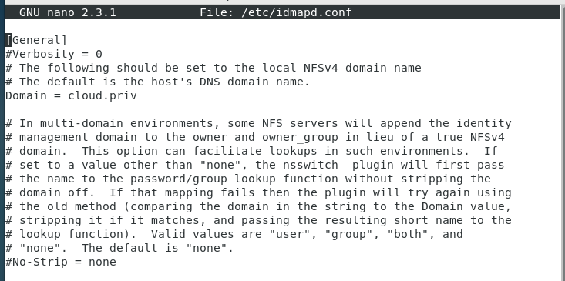

Figure 8, idmapd.conf

Execute the following commands to **enable NFS**:

**service rpcbind start**

**service nfs start**

**chkconfig nfs on**

**chkconfig rpcbind on**

Finally, we finish setting up NFS by creating the following directories to be able to mount our exports folder. **mkdir -p /mnt/primary** and **mkdir -p mnt/primary**.

To test that our storage devices are mountable, run the following command while replacing the IP address with your IP address:

**mount -t nfs 192.168.72.3:/export/secondary /mnt/secondary**

If this runs without errors, check that it is up utilizing the **mount** command. If it is successful, unmount it with the **umount /mnt/secondary** command. You will only want to unmount this folder if you are installing your **VMs on the management server**, which we are. See references [Management Server] for additional information.

Do the same tests for **/primary**. Make sure that when done both **primary** and **secondary** are unmounted.

Then, we will run the command **yum -y install mysql-connector-python** as Java comes preinstalled, but Python does not.

One last prerequisite step before installing the Management Server is to edit the **etc/sudoers** file and add **Defaults:cloud !requiretty** where other defaults are located.

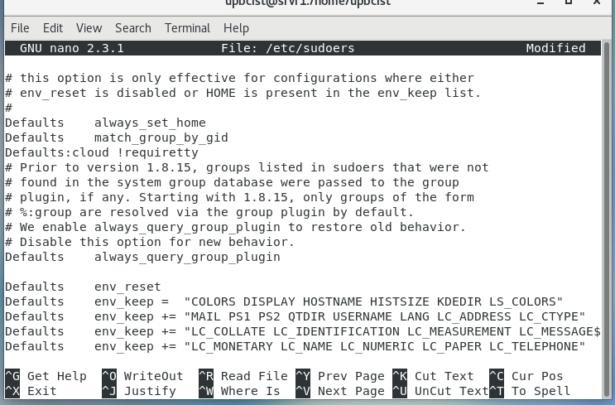

Figure 9, sudoers file

You are now ready to install the Management Server. A reboot and a snapshot are recommended before proceeding. Be sure that all installed services are enabled, and that your network is fully configured.

To install Management Server, run the command **yum install cloudstack-management**

Once finished, run the command **alternatives --config java** and be sure that Java 11 is set, as shown in Figure 10.

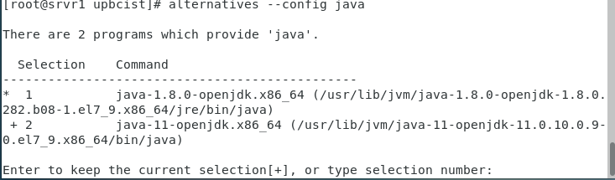

Figure 10, Java config

Reboot the machine and ensure management is running by utilizing the command **systemctl status cloudstack-management**. If management is operating correctly, run the following command:

**cloudstack-setup-databases cloud:<dbpassword>@localhost --deploy-as=root:<root password>**

Once the database is setup, run **cloudstack-setup-management**

Now that CloudStack management is installed, the iptables should be able to function as a service.

Sometimes iptables does not load the configuration file, causing issues with configuration. Once management is installed, a new file should be created outlying cloud stack's rules under **/etc/sysconfig/iptables**. To be sure our rules have been saved and are being utilized by CloudStack, we will once again append the rules we defined earlier to this file in the input section:

iptables -A INPUT -p tcp -m state --state NEW -m tcp --dport 22 -j ACCEPT

iptables -A INPUT -p tcp -m tcp --dport 111 -j ACCEPT

iptables -A INPUT -p tcp -m tcp --dport 892 -j ACCEPT

iptables -A INPUT -p tcp -m tcp --dport 32803 -j ACCEPT

iptables -A INPUT -p tcp -m tcp --dport 32769 -j ACCEPT

iptables -A INPUT -p tcp -m tcp --dport 2049 -j ACCEPT

iptables -A INPUT -p tcp -m tcp --dport 875 -j ACCEPT

iptables -A INPUT -p tcp -m tcp --dport 662 -j ACCEPT

iptables -A INPUT -p tcp -m tcp --dport 16514 -j ACCEPT

iptables -A INPUT -p tcp -m tcp --dport 9090 -j ACCEPT

iptables -A INPUT -p tcp -m tcp --dport 8080 -j ACCEPT

iptables -A INPUT -p tcp -m tcp --dport 3922 -j ACCEPT

iptables -A INPUT -p tcp -m tcp --dport 53 -j ACCEPT

iptables -A INPUT -p tcp -m tcp --dport 49152:49216 -j ACCEPT

iptables -A INPUT -p tcp -m tcp --dport 5900:6100 -j ACCEPT

iptables -A INPUT -p tcp -m tcp --dport 1798 -j ACCEPT

iptables -A INPUT -p tcp -m tcp --dport 22 -j ACCEPT

iptables -A INPUT -p tcp -m tcp --dport 8443 -j ACCEPT

iptables -A INPUT -p tcp -m tcp --dport 8250 -j ACCEPT

iptables -A INPUT -p tcp -m tcp --dport 16509 -j ACCEPT

iptables -A INPUT -p tcp -m tcp --dport 1798 -j ACCEPT

Save the file with **iptables-save**. Verify that all of the ports listed are listed when running the command. See Note 8

Once finished, the last thing you will have to do is add the systemvm template for KVM. Run the following command:

**/usr/share/cloudstack-common/scripts/storage/secondary/cloud-install-sys-tmplt -m /export/secondary -u http://download.cloudstack.org/systemvm/4.15/systemvmtemplate-4.15.0-kvm.qcow2.bz2 -h kvm -F**

This may take a few minutes to finish. Once it is done, you have setup your Management Server, and are now ready to install the Agent.

Run the command **yum install -y epel-release** and, once done, install the agent by utilizing the command **yum install cloudstack-agent**

We will now configure the virtualization manager of the host, which is **libvirt**. Edit the **/etc/libvirt/libvirtd.conf** file and uncomment the following lines:

listen_tls = 0

listen_tcp = 1

tcp_port = "16509"

auth_tcp = "none"

mdns_adv = 0

Then, edit the **/etc/sysconfig/libvirtd** file and uncomment **#LIBVIRTD_ARGS="--listen"** line.

Finally, edit the **/etc/libvirt/qemu.conf** fileand uncomment the line **vnc_listen=0.0.0.0** and then reboot the machine.

Now that everything installed, we will need to check once more to make sure our vital services are running and operational. The agent sometimes is not enabled by default, so be sure to enable and start the service and then reboot to verify. Some services you should check with the following commands: **systemctl status [x]** with **x** being **libvirtd**, **cloudstack-management**, **cloudstack-agent**, **network**, **NetworkManager**, and **nfs**.

It will also be wise to run the command **journalctl -xe** to check for additional problems. Errors should be addressed before configuration. An error concerning SSL can generally be ignored until after configuration is complete.

# Configuration

You can now access your client by going into your browser, and in the search bar, typing in the url: http://<yourIPAddress>:8080/client

Your login username should be **admin**, and your password should be **password**.

When inside of the interface, click on **continue with installation**. It will ask for you to change your username and password. Do so and proceed. It is recommended you take a look at **[Cloudstack Configuration]** in **resources** for information on how you will want to configure your Cloudstack Install.

It will first ask you if you would like to create a security group.

*"Guest isolation can be provided through layer-3 means such as security groups (IP address source filtering)."*

For this installation, I have elected to **not** enable a security group. Clicking continue, CloudStack will ask you to define a **Zone**. Required fields are the name, IPv4 DNS1, Internal DNS 1, and Hypervisor.

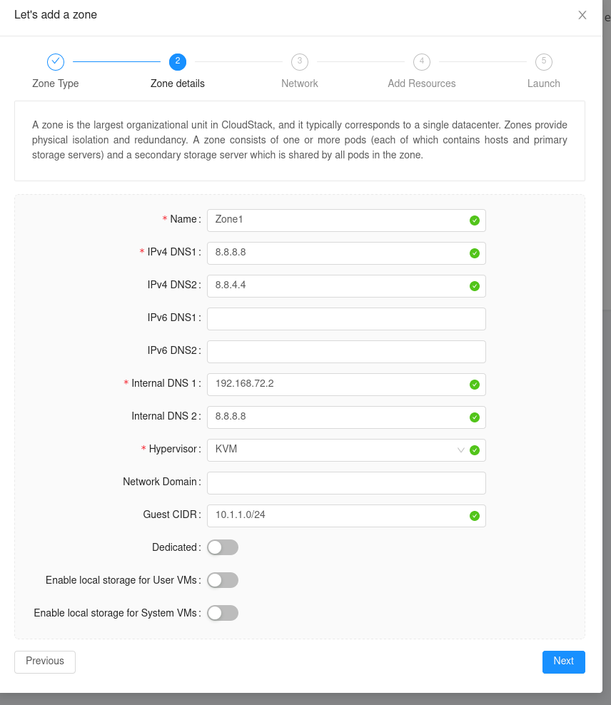

Figure 11, Zone Config

Under network, you can leave your Physical Network as default, as shown in Figure 12.

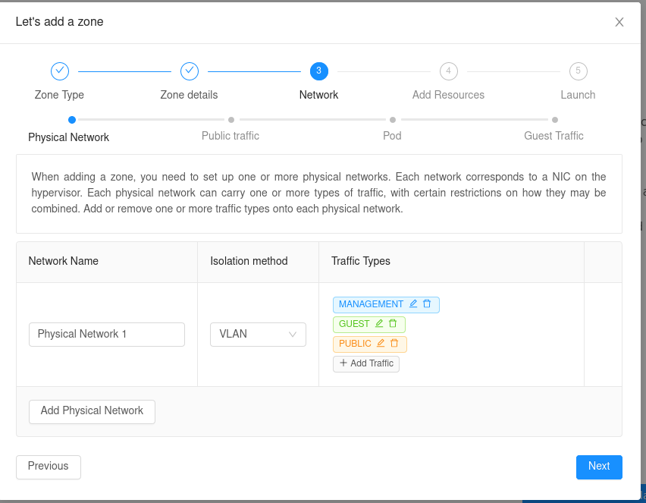

Figure 12, Physical Network

You will then be asked to configure your public traffic. Fill in the information similarly to Figure 13.

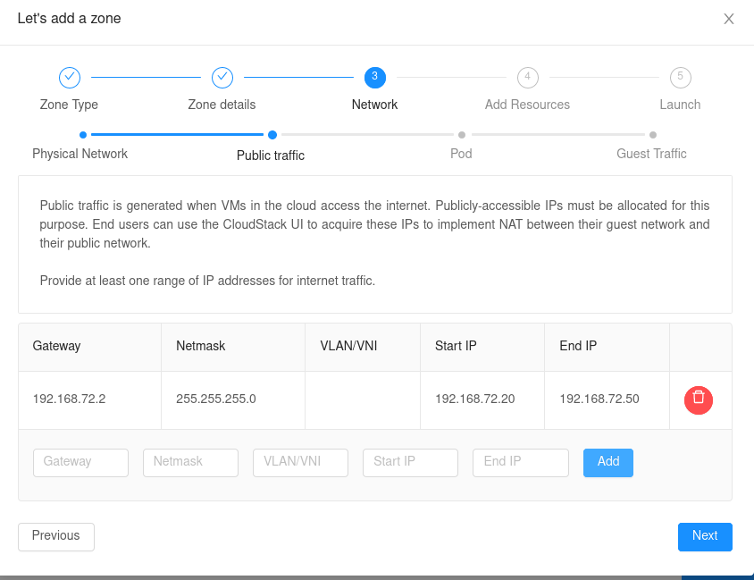

Figure 13, Public Traffic

Then configure your pod. Select the range of reserved system IP's as shown in Figure 14.

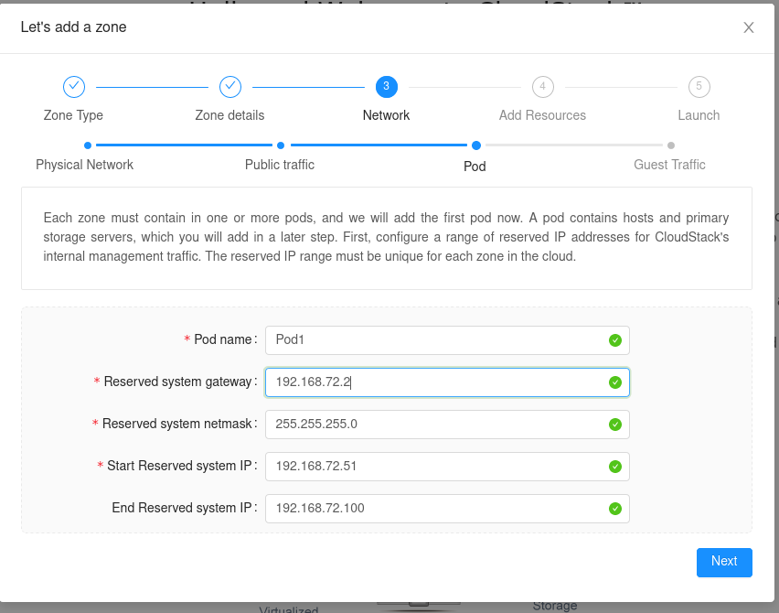

Figure 14, Pod Config

Then, configure your guest network as so:

After configuring your guest network, CloudStack will ask you for your VLAN range. I used the vlan range of 700-900 as shown in Figure 15:

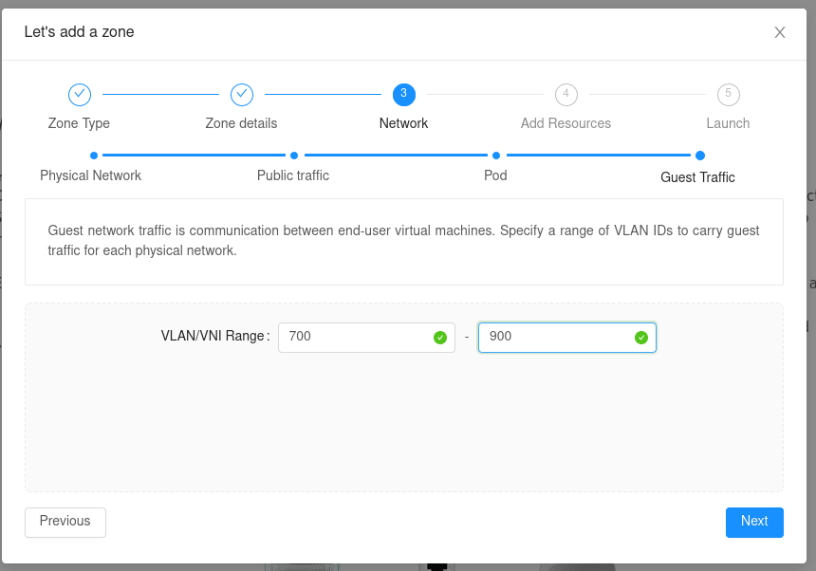

Figure 15, Vlan Range

Click next and then give your Cluster a name.

Give your host the name of your host IP address, followed by the login of root / password of the root user on your host, as shown in Figure 16.

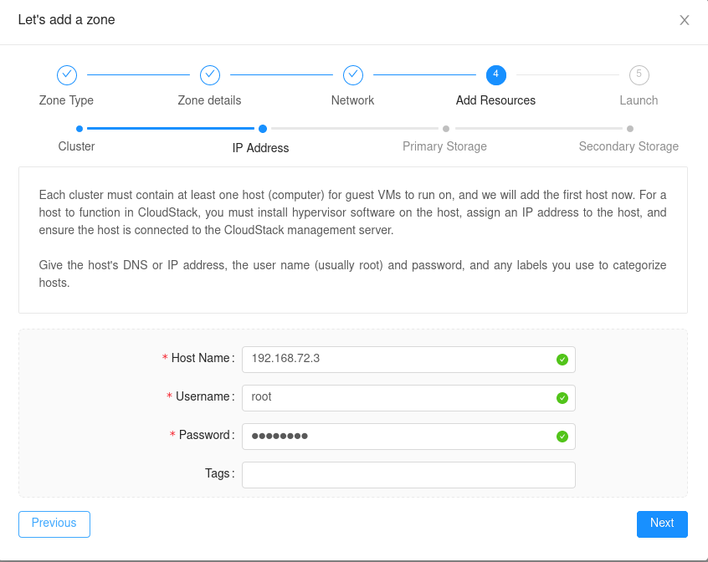

Figure 16, Host Config

Then, configure your primary storage as shown in Figure 18. Be sure to select **nfs** as the protocol. The server is the host IP address, and the path is the **/export/** directories we made earlier. Do the same for your secondary storage, substituting secondary for primary.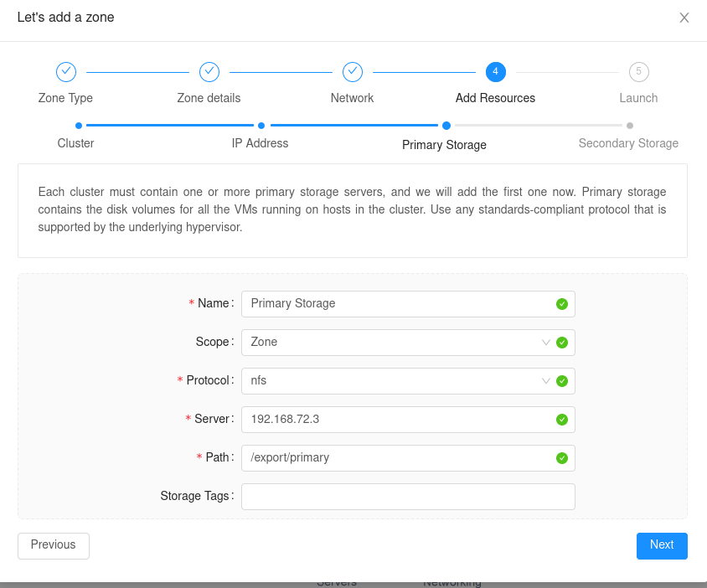

Figure 17, Storage Config

Once done, hit install. If you encounter any errors, verify that your iptables are configured correctly. Wait a few minutes for everything to initialize before configuring CloudStack. Test your connection by navigating to **infrastructure** and clicking on your **secondarystoragevm**. If it is up and running, and you are able to connect to it, then you should have an operational installation. It will also be good practice to run the health check as stated in note 5.

At this stage, you have completed your installation. Please see **results** or proceed to the next section for some tips on utilizing Apache CloudStack.

# Usage Tips

## Creating a Virtual Private Cloud

This is a quick and easy way to setup networking for your instances. Utilizing this, your instances should be able to get out to the internet, as well as connect to other instances on that private network. CloudStack defines a VPC as:

*"CloudStack Virtual Private Cloud is a private, isolated part of CloudStack. A VPC can have its own virtual network topology that resembles a traditional physical network. You can launch VMs in the virtual network that can have private addresses in the range of your choice, for example: 10.0.0.0/16. You can define network tiers within your VPC network range, which in turn enables you to group similar kinds of instances based on IP address range*

*For example, if a VPC has the private range 10.0.0.0/16, its guest networks can have the network ranges 10.0.1.0/24, 10.0.2.0/24, 10.0.3.0/24, and so on"* (VPC, 1).

To configure this, go to **Network** -> **VPC** -> **Add VPC**

Give the VPC a name and a description, and tell it what Zone it should be added to. The CIDR is the private network that you want this VPC to have. It should be a common private network range, according to RFC 1918/RFC 1597. Configure it similarly to Figure 18.

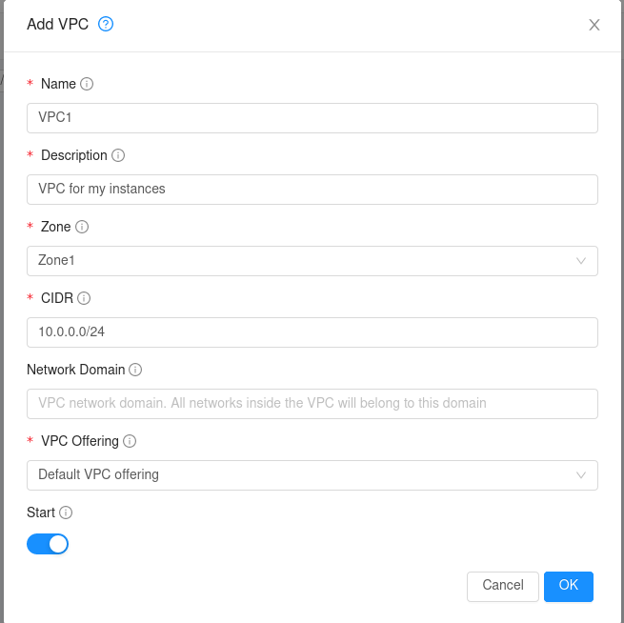

Figure 18, VPC Config

Hit OK and continue. Once the VPC is setup, it should be listed in that same section. Click on the name and it will take you to the VPC configuration page. Go to **Networks** and click **Add Network**. Configure it similarly to Figure 19. The gateway is the gateway of your local network.

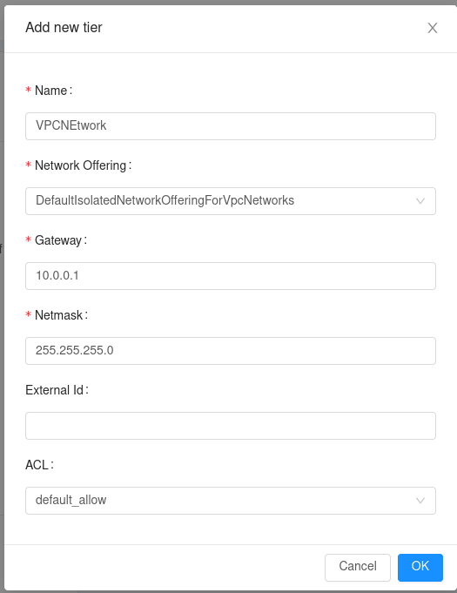

Figure 19, VPC Network Config

Click **OK**. In order to create the virtual router needed, you will need to create an instance with that network.

### Adding an Instance

Instances can be created in **Instances** -> **Add Instance**. Be sure to select your network in the Networks section of instance creation. You can leave the IP address and the MAC address blank if you want CloudStack to automatically configure that for you. Once done, CloudStack will automatically begin creating the instance.

Click on the name of the Instance and then click on the **shell** icon in the top right. This will launch a connection to the instance within the browser.

Once done, the virtual router will be created and assigned a public IP address. The instance will be assigned a private IP address. So long as you configure your instance correctly, you should have a working networking solution utilizing VPC!

### Uploading ISO / Template Creation

This section will show how to upload an ISO and then create a system template utilizing that same ISO within CloudStack. Before beginning, see the **Notes** section and understand the issue with uploading ISO's locally. For this example, we will be **registering** a **Windows Server 2016** ISO from <https://www.microsoft.com/en-us/evalcenter/evaluate-windows-server-2016>.

First, navigate to **Images** -> **ISOs**. There, click on **+ Register ISO**. There, you will need to input some requested information. Fill it out similarly to Figure 20.

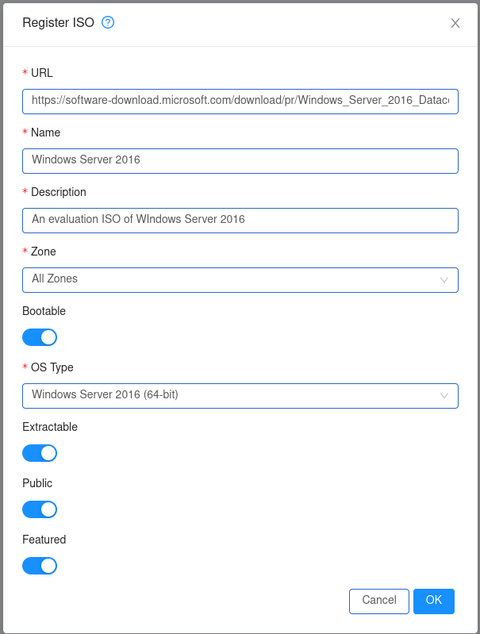

This should be pretty self-explanatory. The **URL** is the link to the ISO you want. Bootable lets CloudStack know that this ISO is a bootable disc. **OS Type** is used to help CloudStack prepare your ISO and makes assumptions to improve performance for the guest. **Extractable** makes it so that the ISO is available for extraction, **Public** allows for other users to access the ISO, and **Featured** will allow for the ISO to be easily selected when creating an instance.

Once done, CloudStack will begin downloading the ISO. This may take a while. Once done, create an instance utilizing that ISO and install your operating system. Configure your operating system how you would like it.

Everything up to this point should be universal for all operating systems. Now however, the process may change. This guide will continue on with creating a Windows template, which involves sysprepping the machine. Be sure to look up if there are any specific requirements for creating a template with your operating system before creating the template. The template creation procedure should be universal and is listed below.

<http://docs.cloudstack.apache.org/projects/cloudstack-administration/en/4.8/templates/_create_windows.html>

On the VM, **install cloud-init** from <https://cloudbase.it/cloudbase-init/>. Just run the tool, selecting sysprep once finished and then shutdown. Once its done shutting down, proceed to the next step.

Stop the virtual machine. Then, go to **Volumes**. You should see at least one volume, which should be called ROOT. Click on it, then in the top right corner of the volume select **Create Template from Volume**. Change the settings as you desire, then click **OK**. Your template will now start to be created.

Figure 20, Register ISO Config

## Customizing Basic UI

CloudStack allows for an easy way to modify the basic UI through the use of an editable configuration file. Basic configuration includes modifying the colors of different CloudStack views, the logos, heights and widths of views, and more. This section will describe the process of modifying the CloudStack logo.

First, acquire a logo you would like to use and save it to the **/usr/share/cloudstack-management/webapp/assets** folder. Next, navigate to **/usr/share/cloudstack-management/webapp/config.json**. This file should look similar to Figure 20.

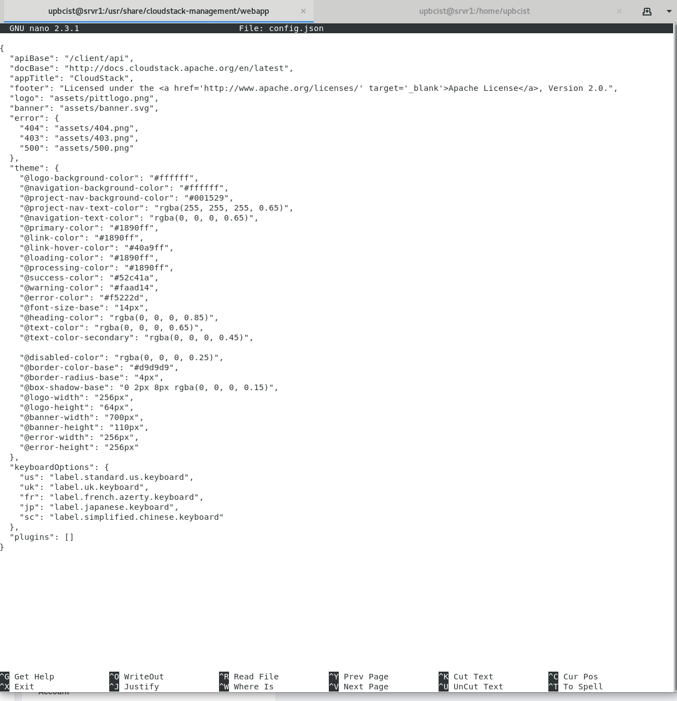

Figure 21, Config.json

At the top, modify the "logo" variable and set it to "**assets/<yourlogoname>**" along with the file extension. Then, log on to Apache CloudStack, and you should see your new logo in the top left corner. To modify the size of the logo, scroll down in the **config.json** file and change the **@logo-height** and **@logo-width** values. This same process can also be done for the banner on the login page.

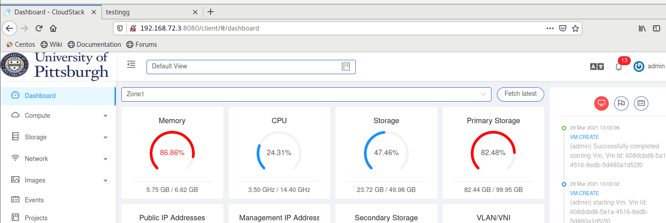

Figure 22, UI Change

This section showed the path to the basic configuration file and how to edit the values to make simple changes to the user interface of CloudStack. Advanced UI customization is possible only by changing JavaScript based config files which define rules for sections, names, icons, actions and components and by building the UI from the source available on github.com/apache/cloudstack repository.

# Results

You should hopefully have a working Apache CloudStack installation running. You also know how to deploy an "Advanced Network" for your installation. You should also now know how to utilize some features of CloudStack, including creating a Virtual Private Cloud and modifying the user interface. Please see the notes and references for additional information and questions.

# Notes

This section will include general advice, troubleshooting aid, and additional information.

1. It is recommended to reboot the system instead of restarting a service whenever possible.
2. The network may stop working if booting from a saved state. Rebooting should fix the issue.
3. You may encounter an error when attempting to add an ISO or Template to CloudStack. You will need to configure your SSL certificates to make this happen, as it will only work with a secure HTTPS connection. See "**Uploading ISO**" reference for more information.
4. Upon reboot after installing CloudStack-Management, Cloud Stack’s system VM’s and instances may be reported as up but will be unable to connect. For some reason, iptables becomes a service that is able to be started and stopped. If you run **systemctl enable iptables** and **systemctl start iptables**, it should fix the issue (give it a minute). I am unsure why this happens. If you attempt to run those commands earlier in this guide, centos will reply that iptables is not a service.
5. To troubleshoot the secondary storage, or to run the health check, please see the “**Troubleshooting Secondary Storage**” reference.
6. When accessing a virtual machine, there is a hard to see bar on the left side of the screen within the browser. This is where you can pass in commands such as clipboard and “Control Alt Delete” to the virtual machine.
7. A possible bug fix for issues with your storage is to access the global configuration settings within CloudStack UI and set secstorage.allowed.internal.sites = <your network>
8. If your SSL errors are crippling your installation, you may need to disable the ca.auth configuration in global settings.
9. Agent and Management logs are in /var/logs/cloudstack/.
10. To be triple sure my iptables have saved, I manually added the iptables list to the **/etc/sysconfig/iptables** file. This shouldn't be required, but if your systemvms and instances are unable to connect, you should try doing this.

# References

[Agent Install] Apache Foundation. “Host KVM Installation — Apache CloudStack 4.15.0.0 Documentation.” Apache CloudStack, Apache Foundation, 2021, <https://docs.cloudstack.apache.org/en/latest/installguide/hypervisor/kvm.html>

[Management Server Install] Apache Foundation. “Management Server Installation — Apache CloudStack 4.15.0.0 Documentation.” Apache CloudStack, A, 2021, <http://docs.cloudstack.apache.org/en/latest/installguide/management-server/index.html>

[Quick Installation Guide] “Quick Installation Guide — Apache CloudStack 4.15.0.0 Documentation.” Apache CloudStack, Apache Foundation, 2021, <http://docs.cloudstack.apache.org/en/latest/quickinstallationguide/qig.html>

[VPC]Apache Software Foundation. “Configuring a Virtual Private Cloud.” Apache Docs, 2016, docs.cloudstack.apache.org/projects/archived-cloudstack-http://docs.cloudstack.apache.org/projects/archived-cloudstack-administration/en/latest/networking/virtual_private_cloud_config.html

[Cloudstack Configuration] Apache Software Foundation. “Configuring Your CloudStack Installation — Apache CloudStack 4.15.0.0 Documentation.” Apache Cloudstack, Apache Software Foundation, 2021, <http://docs.cloudstack.apache.org/en/latest/installguide/configuration.html#initialize-and-test>

Apache Software Foundation. “Log In to the UI.” Apache CloudStack Docs, Apache Software Foundation, 2021, <https://docs.cloudstack.apache.org/en/latest/adminguide/ui.html>

[Mailing List for Questions, Strong Troubleshooting Reference] Apache Software Foundation. “Pony Mail!” Pony Mail, Apache Software Foundation, 2021, <https://lists.apache.org/list.html?users@cloudstack.apache.org>

[Uploading ISO] “Working With Templates.” Apache CloudStack, Apache Software Foundation, 2021, <https://docs.cloudstack.apache.org/en/latest/adminguide/templates.html>

[Troubleshooting Secondary Storage] Prasanna. “SSVM, Templates, Secondary Storage Troubleshooting.” Cwiki Apache, cwiki, 2014, <https://cwiki.apache.org/confluence/display/CLOUDSTACK/SSVM,+templates,+Secondary+storage+troubleshooting>

[New Total Learners Resource on CloudStack] ShapeBlue. “Shapeblue/Hackerbook.” GitHub, Apache Software Foundation, 2021, <https://github.com/shapeblue/hackerbook>

[Some Ports Used By Cloudstack]Yadav, Rohit. “Ports Used by CloudStack.” Cwiki, Apache Foundation, 2013, <https://cwiki.apache.org/confluence/display/CLOUDSTACK/Ports+used+by+CloudStack>

[CloudStack Configuration] “Rohit Yadav - Apache CloudStack on Ubuntu with X86_64 KVM.” Rohit Yadav, Rohit Yadav, 4 July 2019, <https://rohityadav.cloud/blog/cloudstack-kvm>